⦁ **Look at the data given below. Plot the data, find the outliers and find out**

|  |  |
| --- | --- |
| **Name of company** **Measure X** | **Measure X** |
| Allied Signal | 24.23% |
| Bankers Trust | 25.53% |
| General Mills | 25.41% |
| ITT Industries | 24.14% |
| J.P.Morgan & Co. | 29.62% |
| Lehman Brothers | 28.25% |
| Marriott | 25.81% |
| MCI | 24.39% |
| Merrill Lynch | 40.26% |
| Microsoft | 32.95% |
| Morgan Stanley | 91.36% |
| Sun Microsystems | 25.99% |
| Travelers | 39.42% |
| US Airways | 26.71% |
| Warner-Lambert | 35.00% |

Answer: -

The following is the outlier in the boxplot: Morgan Stanley 91.36%

measure_x.describe()

Mean = 33.271333

Standard deviation = 16.945401

measure_x.var()

Variance = 287.1466123809524

**⦁Answer the following three questions based on the box-plot below.**

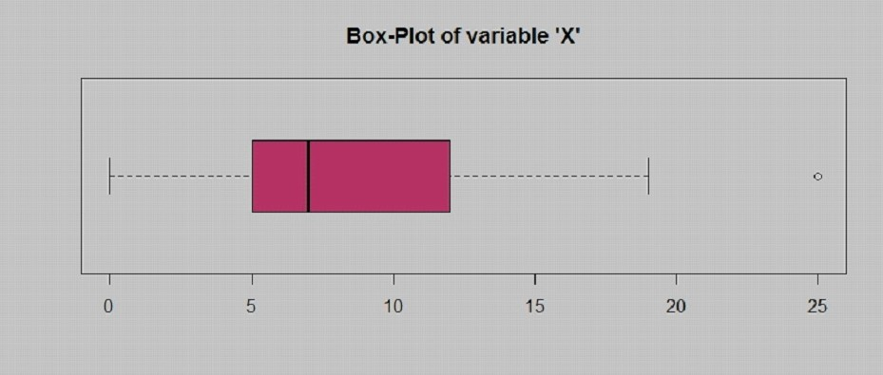

**⦁** **What is inter-quartile range of this dataset? (please approximate the numbers) In one line, explain what this value implies.**

Answer: -

Approximately (First Quantile Range) Q1 = 5 (Third Quantile Range) Q3 = 12, Median (Second Quartile Range) = 7

(Inter-Quartile Range) IQR = Q3 – Q1 = 12 – 5 = 7

Second Quartile Range is the Median Value

**⦁** **What can we say about the skewness of this dataset?**

Answer: -

Right-Skewed median is towards the left side it is not normal distribution

**⦁** **If it was found that the data point with the value 25 is actually 2.5, how would the new box-plot be affected?**

Answer: -

In that case there would be no Outliers on the given dataset because of the outlier the data had positive skewness it will reduce and the data will normal distributed

**⦁ Answer the following three questions based on the histogram below.**

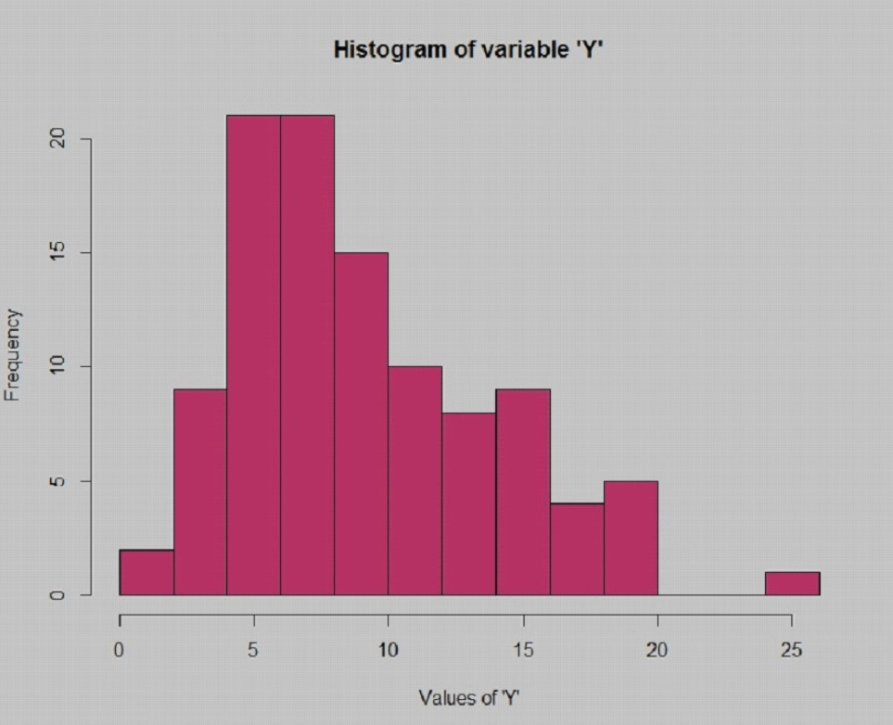

**⦁** **Where would the mode of this dataset lie?**

Answer: - The mode of this data set lie in between 5 to 10 and approximately between 4 to 8 .

**⦁** **Comment on the skewness of the dataset.**

Answer: - Right-Skewed. Mean>Median>Mode

**⦁** **Suppose that the above histogram and the box-plot in question 2 are plotted for the same dataset. Explain how these graphs complement each other in providing information about any dataset.**

Answer: - They both are right-skewed and both have outliers the median can be easily visualized in box plot where as in histogram mode is more visible.

⦁ **AT&T was running commercials in 1990 aimed at luring back customers who had switched to one of the other long-distance phone service providers. One such commercial shows a businessman trying to reach Phoenix and mistakenly getting Fiji, where a half-naked native on a beach responds incomprehensibly in Polynesian. When asked about this advertisement, AT&T admitted that the portrayed incident did not actually take place but added that this was an enactment of something that “could happen.” Suppose that one in 200 long-distance telephone calls is misdirected. What is the probability that at least one in five attempted telephone calls reaches the wrong number? (Assume independence of attempts.)**

Answer: -

IF 1 in 200 long-distance telephone calls are getting misdirected.

probability of call misdirecting = 1/200

Probability of call not Misdirecting = 1-1/200 = 199/200

The probability for at least one in five attempted telephone calls reaches the wrong number

Number of Calls = 5

n = 5

p = 1/200

q = 199/200

P(x) = at least one in five attempted telephone calls reaches the wrong number

P(x) = ⁿCₓ pˣ qⁿ⁻ˣ

P(x) = (nCx) (p^x) (q^n-x) # nCr = n! / r! * (n - r)!

P(1) = (5C1) (1/200)^1 (199/200)^5-1

P(1) = 0.0245037

**⦁ Returns on a certain business venture, to the nearest $1,000, are known to follow the following probability distribution**

|  |  |
| --- | --- |
| x | P(x) |
| -2000 | 0.1 |
| -1000 | 0.1 |
| 0 | 0.2 |
| 1000 | 0.2 |
| 2000 | 0.3 |
| 3000 | 0.1 |

Answer: -

E(X) =Sum X.*P(X) | E(X^2) =X^2*P(X)

-200 | 400000

-100 | 100000

0 | 0

200 | 200000

600 | 1200000

300 | 900000

Total: 800 | 2800000

**⦁ What is the most likely monetary outcome of the business venture?**

Answer: -

The most likely monetary outcome of the business venture is 2000$

As for 2000$ the probability is 0.3 which is maximum as compared to others

**⦁ Is the venture likely to be successful? Explain**

Answer: -

Yes, the probability that the venture will make more than 0 or a profit

p(x>0)+p(x>1000)+p(x>2000)+p(x=3000) = 0.2+0.2+0.3+0.1 = 0.8 this states that there is a good 80% chances for this venture to be making a profit

**⦁ What is the long-term average earning of business ventures of this kind? Explain**

Answer: -

long-term average is Expected value = Sum (X * P(X)) = 800$ which means on an average the returns will be + 800$

**⦁What is the good measure of the risk involved in a venture of this kind? Compute this measure**

Answer: -

The good measure of the risk involved in a venture of this kind depends on the Variability in the distribution. Higher Variance means more chances of risk

Var (X) = E(X^2) –(E(X))^2

= 2800000 – 800^2

= 2160000